Quantum Neural Network Approach to Behavioral Fraud Detection Using Timing and Categorical Financial Features

Farheen Shabbir Shaikh
Department of School of Engineering & Computer Science
University of the Pacific
Stockton, California, USA

ORCID:orcid.org/0009-0009-7022-7810

Abstract—Advance-Fee Fraud (AFF) scams exploit urgency and psychological pressure to coerce victims into making rapid upfront payments, making behavioral timing signals a critical component for early detection. In this work, we investigate the effectiveness of a Quantum Neural Network (QNN) for detecting and classifying AFF attacks using engineered behavioral and transactional features. We are using a synthetic financial transaction dataset augmented with account-level behavioral context. Features are derived to capture both global and user-specific scam patterns and user-relative deviation measures for amount and urgency. In particular, the proposed 6-qubit QNN achieves near-perfect recall while maintaining strong correctness, indicating its effectiveness in identifying high-risk scam transactions without excessive false alarms. This study shows that quantum-enhanced models can effectively capture complex behavioral interactions in AFF detection, and that further performance gains may be realized through richer feature encoding and increased qubit capacity as quantum hardware and hybrid deployment strategies mature.

Keywords—Advance-Fee Fraud; Scam Detection; Behavioral Anomaly Detection; Quantum Neural Networks; Financial Cybersecurity; Quantum Machine Learning.

Introduction

Financial fraud has evolved into one of the fastest-growing global cyber risks, with attackers increasingly leveraging psychological manipulation and high-pressure communication tactics to coerce victims into making rapid, irreversible
payments. Among these schemes, Advance-Fee Fraud (AFF) stands out for its ability to exploit urgency: victims are often persuaded to send money within minutes of receiving a
deceptive message. This compressed timeline creates a critical vulnerability—traditional fraud-detection systems often cannot react quickly enough to intervene before the first payment is made. Understanding and modeling these rapid behavioral patterns is therefore essential for developing early-warning systems capable of preventing loss.
Over the past five years, the Federal Bureau of Investigation’s Internet Crime Complaint Center (IC3) has received an average of more than 836{,}000 cybercrime complaints annually, underscoring the escalating scale and diversity of online . Within this landscape, Advance-Fee Fraud (AFF) remains a persistent and economically damaging threat. Although AFF ranks lower in complaint volume compared to phishing or extortion—recording 7097 complaints in 2024—it generates disproportionately severe financial losses, exceeding $102 million in 2024 alone. Historical IC3 records further show that AFF losses consistently surpass $100 million annually, including a peak of $134 million in 2023, highlighting its continued impact. Demographic analyses also reveal that AFF affects victims across all age groups, with individuals aged 30–59 reporting both the highest complaint counts and the largest cumulative losses. Additionally, AFF schemes appear within cryptocurrency-enabled crime, contributing 1537 complaints and more than $36 million in losses, demonstrating the scam’s evolution alongside modern financial platforms. Collectively, IC3 data indicate that AFF is both widespread and highly lucrative for attackers, reinforcing the urgent need for real-time behavioral analytics and advanced detection models such as Quantum Neural Networks (QNNs).
One of the most informative behavioral indicators in Advance-Fee Fraud (AFF) scenarios is the Inter-Payment Interval (IPI), defined as the time gap between the initial scam message and the first outgoing payment. Shorter IPIs strongly correlate with attacker-induced urgency and psychological pressure, making timing-based signals a powerful foundation for early fraud detection. However, relying on a single behavioral indicator is often insufficient to capture the complexity of real-world scam interactions, as attackers vary persuasion strategies across victims and accounts. This motivates the integration of additional behavioral and transactional signals that contextualize urgency within broader interaction patterns.
Quantum Machine Learning (QML) has emerged as a promising research direction, offering highly expressive decision boundaries through quantum state representations and entanglement. Despite growing interest, limited empirical work has examined how Quantum Neural Networks (QNNs) perform on practical, small-scale fraud detection tasks that rely on behavioral and user-specific features. In particular, it remains unclear whether QNNs can effectively leverage correlated behavioral signals—such as urgency, response latency, interaction intensity, and transaction magnitude—more effectively than classical models like Logistic Regression and Support Vector Machines (SVM), which are commonly deployed in financial risk systems.
In this work, we investigate both the detection performance and classification speed of a QNN relative to classical baselines using a set of engineered behavioral and transactional features derived from synthetic financial data. These features include raw urgency signals (IPI), behavioral proxies for response time and message pressure, log-scaled transaction amount, and user-relative deviation measures computed at the bank-account level. By benchmarking accuracy, precision, recall, F1-score, and inference latency across classical and quantum architectures, this study aims to assess the realistic capabilities and trade-offs of QNN-based fraud detection. Our results establish a foundation for future work exploring richer feature encodings, additional qubits, and hybrid quantum–classical deployment strategies as quantum hardware matures.

Motivation
Advance-Fee Fraud (AFF) attacks remain one of the most pervasive and financially damaging forms of cybercrime, primarily because scammers exploit psychological urgency to pressure victims into making rapid and often irreversible payments. This manipulation creates an extremely narrow window for detection, during which abnormal behavioral patterns must be identified before funds are permanently transferred. Urgency-driven actions—such as unusually fast payment decisions, heightened interaction pressure, and abrupt deviations from a victim’s typical transaction behavior—serve as critical early indicators of AFF activity. However, accurately leveraging such limited and tightly coupled behavioral signals in real time remains a significant challenge.
Standard machine-learning models widely used in financial systems are Logistic Regression and Support Vector Machines (SVM), are valued for their computational efficiency and deployment stability; however, they often struggle in urgency-driven fraud scenarios where behavioral datasets are small and features are highly correlated. Their reliance on simplified decision boundaries can limit their ability to capture complex behavioral interactions within the narrow time window available before a fraudulent payment becomes irreversible. Quantum Neural Networks (QNNs) offer a promising alternative by leveraging quantum superposition and entanglement to model multiple feature interactions simultaneously, enabling richer nonlinear representations from compact input spaces. Motivated by these properties, this work evaluates whether a QNN can more effectively detect urgency-driven Advance-Fee Fraud behavior than classical baselines under identical feature constraints, while also examining the trade-offs between detection accuracy and inference latency to assess its suitability for future real-time financial security systems.

Literature Review

Advance-Fee Fraud (AFF) and Behavioral Indicators
Advance-Fee Fraud (AFF) is a widely documented social-engineering scheme in which offenders manipulate victims into sending upfront payments under deceptive pretenses. Leukfeldt and Jansen [1] explain that AFF victimization follows a psychological progression involving trust-building, urgency induction, and staged financial requests. Social-engineering research further reveals that attackers deliberately exploit emotional pressure, perceived authority, and time scarcity to impair rational decision-making [2].
A key behavioral signal relevant to early detection is the Inter-Payment Interval (IPI)—the time between receiving a fraudulent message and initiating the first payment. Prior work demonstrates that temporal response patterns are highly effective indicators of fraud susceptibility, especially in high-pressure scams where victims react within minutes [3]. This motivates the use of IPI as a core numerical–behavioral feature for detecting AFF in real time.

Classical Machine Learning Approaches to Fraud Detection
Classical machine learning has been widely applied to financial fraud analytics due to its efficiency and stability. Anusha and Amutha [4] provide a comprehensive review showing that models such as Logistic Regression (LR) and Support Vector Machines (SVM) are commonly used because of their interpretability and low computational cost.
LR, grounded in statistical learning theory [5], offers fast inference but is constrained by its linear decision boundaries, making it less effective in cases involving nonlinear behavioral signals. Similarly, Hosmer et al. [6] highlight LR’s sensitivity to feature scaling and its limitations with small or imbalanced datasets.
SVMs, introduced by Vapnik [5], provide stronger nonlinear modeling capabilities when kernel functions such as the radial basis function (RBF) are used. However, inference latency increases with the number of support vectors, which may hinder real-time fraud detection when behavioral features are sparse or rapidly evolving.

Quantum Machine Learning and the Emergence of QNNs
Quantum Machine Learning (QML) has gained momentum as a potential alternative to classical models, especially for tasks involving complex decision boundaries. Schuld et al. [7] describe the conceptual foundations of quantum neural networks (QNNs), highlighting their ability to embed data into high-dimensional Hilbert spaces.
More recent work by Schuld and Killoran [8] formalizes the use of feature Hilbert spaces for quantum learning, enabling classical features to be encoded directly into quantum states. Abbas et al. [9] further demonstrate that QNNs can express highly nonlinear functions with fewer trainable parameters than deep neural networks, suggesting potential advantages for fraud detection when feature sets are compact.

Parametrized Quantum Circuits (PQCs)
Parametrized Quantum Circuits (PQCs) serve as the core computational units of QNNs. Preskill [10] emphasizes that PQCs are particularly suited to the Noisy Intermediate-Scale Quantum (NISQ) era due to their hybrid design and compatibility with classical optimization.
Bergholm et al. [11] show that modern frameworks such as PennyLane enable automatic differentiation across quantum and classical components, making PQCs practical for supervised fraud-detection tasks. Additionally, Lloyd et al. [12] demonstrate that quantum circuits can be trained for classification through variational optimization, providing a mechanism for QNN-based decision-making.

Fraud Landscape and Motivation for Real-Time Detection
The 2024 Internet Crime Report [13] highlights that financial fraud continues to grow in scale, with losses increasingly driven by fast-moving scams such as AFF. Since many victims respond within minutes of initial contact, detection systems must operate within strict latency constraints.
Furthermore, visual models of the social-engineering attack lifecycle [14] illustrate how psychological manipulation unfolds across distinct stages. This progression reinforces the need for behavior-aware detection—particularly the use of timing-based features such as IPI—to identify AFF before payment occurs.

Background

Advanced-Fee Fraud (AFF) and Behavioral Indicators
Advance-Fee Fraud (AFF) is a form of social-engineering attack in which scammers persuade victims to transfer money upfront under false pretenses (Leukfeldt & Jansen, 2020). AFF techniques follow the broader psychological manipulation cycle used in social engineering: attackers investigate the victim, establish a persuasive hook, execute the fraudulent play, and finally exit while covering their tracks. These interactions rely heavily on urgency cues, emotional pressure, and manufactured opportunity, all of which significantly reduce a victim’s decision-making time (Hadnagy, 2018).
A key behavioral signal arising from this manipulation is the Inter-Payment Interval (IPI), a numerical–behavioral hybrid feature representing the time elapsed between receiving the scam message and sending the first payment. Prior research shows that urgency-driven attacks shorten victim response time and therefore require temporal features for effective early-stage fraud detection (Narayanan et al., 2019). In AFF scenarios, modeling such timing behavior is essential for detecting the scam before monetary loss occurs. A visual illustration of the social-engineering lifecycle is shown in Image 1.
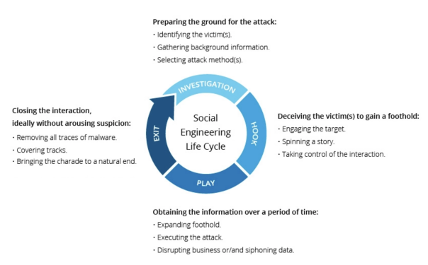
Image 1: The Social Engineering Lifecycle illustrating the stages of an AFF-style scam.

Advanced-Fee Fraud (AFF) and Numeric Indicators

Classical Machine Learning for Binary Classification
Classical machine-learning models are widely used in fraud analytics due to their efficiency, robustness, and interpretability[3].

Logistic Regression (LR) : Logistic Regression models the probability of a binary outcome using a logistic function [7]. Although computationally lightweight, LR is limited to learning linear decision boundaries and may underperform when fraud patterns exhibit nonlinear relationships.

Support Vector Machine (SVM): Support Vector Machines project data into higher-dimensional spaces to find an optimal separating hyperplane [5]. When paired with nonlinear kernels such as the RBF kernel, SVMs can model complex decision boundaries even in small datasets. However, inference time depends on the number of support vectors, causing classification speed to vary based on feature selection and model complexity.

Quantum Machine Learning and Quantum Neural Networks

Quantum Machine Learning (QML) integrates quantum computation with classical optimization methods and has gained interest for its potential to learn complex patterns using compact representations (Schuld et al., 2014). This study employs a Quantum Neural Network (QNN) based on Parametrized Quantum Circuits (PQCs).

Parametrized Quantum Circuits (PQCs) : PQCs consist of trainable quantum gates applied to qubits, combined with feature-encoding rotations that embed classical data into the quantum state space (Schuld & Killoran, 2019). During training, the parameters of these gates are optimized to minimize a classical loss function. Encoded features E(x) pass through a variational circuit U(θ), whose measurement outcomes provide expectation values used by the QNN. By leveraging the high-dimensional Hilbert space of quantum states, QNNs may capture complex decision boundaries even with a small number of input features. Figure 2 presents the PQC architecture used in this study, demonstrating the flow from classical features to quantum encoding, variational layers, measurement, and final classification output.

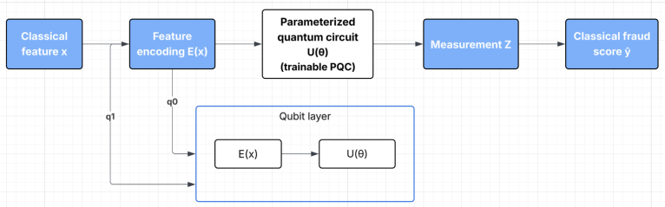
Image 2: Parameterized Quantum Circuit (PQC) architecture used in this study. Classical features—such as the Inter-Payment Interval (IPI) and additional numerical fraud indicators—are first encoded into qubit rotations. These encoded features are then processed by a trainable variational quantum circuit U(θ). The resulting quantum state is measured to obtain expectation values, which are converted into a classical fraud score ŷ.

Quantum Simulation Overhead : Because current experiments run on classical hardware rather than true quantum processors, simulation cost scales exponentially with qubit count and circuit depth. Frameworks such as PennyLane allow hybrid quantum-classical modeling but inherit these simulation constraints, resulting in significantly slower inference times than classical machine-learning models [11].

Quantum Feature Encoding : To apply quantum algorithms to classical datasets, input features must be transformed into quantum states that can be processed by a quantum circuit, a process commonly referred to as quantum feature encoding or data loading. This operation is analogous to feature mapping in classical machine learning, where data is embedded into a higher-dimensional space to enable more expressive decision boundaries. Quantum feature encoding represents classical inputs using parameterized quantum gates, such as rotation-based encodings, allowing the quantum circuit to perform nonlinear transformations through superposition and entanglement. In this work, behavioral and transactional features are encoded via rotation-based mappings, enabling the QNN to efficiently model urgency-driven fraud patterns within a compact quantum representation [15].

Dense angle encoding in Quantum Machine Learning :
In quantum machine learning (QML), the choice of data encoding plays a critical role in determining the expressive power and efficiency of quantum neural networks (QNNs). One commonly used approach is angle encoding, where each classical feature is mapped to a rotation angle of a single-qubit gate. However, standard angle encoding requires one qubit per feature, which can limit scalability when the number of features increases.
To address this limitation, Dense Angle Encoding (DAE) has been proposed as a more compact encoding strategy. Dense angle encoding is a hybrid of angle encoding and phase encoding, allowing two classical features to be embedded into a single qubit.

Dense Angle Encoding Principle
Given two normalized classical features xk(j) and xl(j) from the j-th data sample, dense angle encoding maps them to a single qubit state using consecutive rotations around the Y and Z axes:
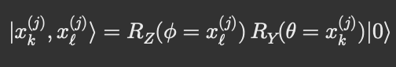
This results in the quantum state:
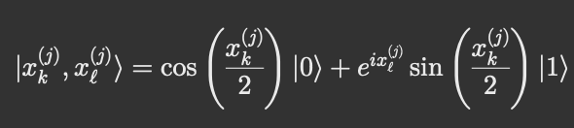
Here:
- RY(θ) encodes feature magnitude into probability amplitudes
- RZ(φ) encodes an additional feature into the relative phase
As a result, each qubit encodes two features instead of one, achieving a 2× reduction in qubit requirements.

Extension to Multi-Feature Data
For a feature vector x = (x1, x2,…, xN)
dense angle encoding maps the data into a quantum state using N/2 qubits:
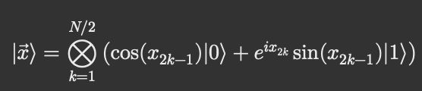
This encoding significantly improves qubit efficiency and is particularly attractive for near-term quantum devices with limited qubit counts.

Methodlogy
This study evaluates the effectiveness of a Quantum Neural Network (QNN) for detecting Advance-Fee Fraud (AFF) using behavioral and transactional indicators, and compares its performance against two classical baselines: Logistic Regression (LR) and Support Vector Machines (SVM). The methodology consists of dataset construction, feature engineering, model architectures, and evaluation protocols.

Dataset and Preprocessing
A synthetic financial transaction dataset was constructed to simulate early-stage AFF interactions, where detection must occur before an irreversible payment is completed. The dataset contains N =2000 samples and is intentionally imbalanced to reflect real-world fraud prevalence, consisting of 80% non-fraudulent and 20% fraudulent instances. Fraudulent samples were parameterized to exhibit urgency-driven behavior, while non-fraudulent samples followed slower, less pressured patterns. All features were normalized to the [0,1] range prior to training to ensure consistency across classical and quantum models.
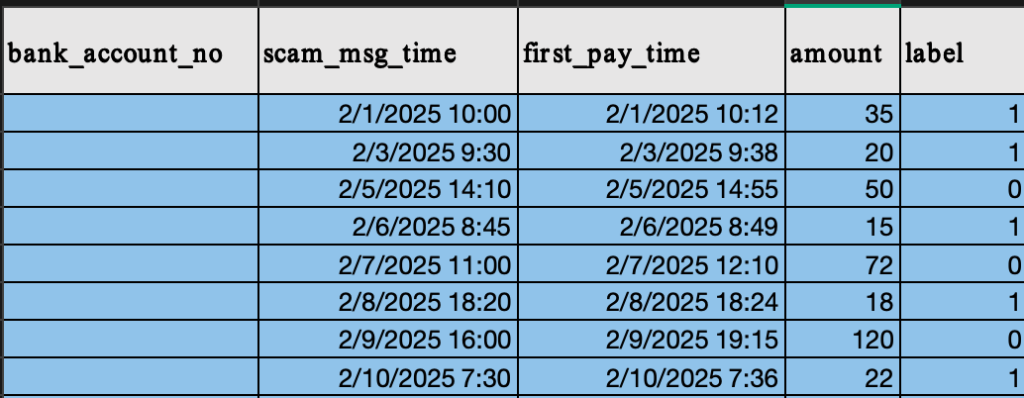
Image 3:Sample rows from the synthetic Advance-Fee Fraud (AFF) transaction dataset. Each record represents a single user interaction, including the scam message timestamp, first payment timestamp, transaction amount, and ground-truth fraud label. Behavioral features such as urgency are derived from the temporal relationship between message and payment events. To ensure data quality and numerical stability:
- Timestamp fields (scam_msg_time, first_pay_time) were parsed into datetime objects.
- Records with invalid or missing timestamps or labels were removed.
- Transaction amounts were converted to numeric format and cleaned of invalid entries.
- Missing account identifiers were replaced with synthetic placeholders to preserve sequential grouping.
This dataset includes several behavioral and numerical indicators commonly associated with Advance-Fee Fraud (AFF) patterns:

bank_account_no: A unique identifier representing the user’s bank account.
This column provides account-level context, enabling transactions to be grouped by user. While it is not directly used as a numerical input feature, it supports structural realism and allows future extensions such as:
- User-relative behavioral baselines
- Historical deviation analysis
- Multi-transaction fraud patterns
To prevent data leakage, the account identifier is excluded from model training.

scam_msg_time : The timestamp at which a scam-related message was received by the user. Serves as the starting reference point for measuring urgency-driven behavior. This timestamp is used to derive temporal features that capture how quickly a victim reacts after being contacted.

first_pay_time : The timestamp corresponding to the user’s first outgoing payment attempt following the scam message. The timestamp corresponding to the user’s first outgoing payment attempt following the scam message. Together with scam_msg_time, this column enables the computation of behavioral timing features that quantify urgency and pressure, which are critical indicators in Advance-Fee Fraud scenarios.

amount : The monetary value of the first transaction initiated by the user after receiving the message. This feature captures the financial magnitude of the interaction. In Advance-Fee Fraud, initial payments are often small “verification” or “processing” fees. The raw amount is later log-scaled during feature engineering to stabilize variance.

label : The ground-truth class label indicating whether the interaction corresponds to an Advance-Fee Fraud attempt.

1 → Fraud (AFF); 0 → Non-fraud (Legitimate)

Used as the target variable for supervised learning. Fraud labels are assigned such that fraudulent cases exhibit urgency-consistent behavioral patterns (shorter response times).

Feature Engineering
A fixed six-feature representation (6F) was derived for all models to ensure fair comparison:
- Inter-Payment Interval (IPI): Time difference (in minutes) between the scam message and the first payment request.
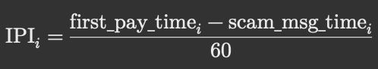
- Response Time Proxy: Time gap (in minutes) between consecutive scam messages for the same account.
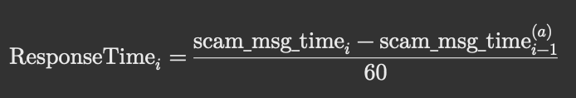
- Message Count Proxy: An estimated count of scam messages, derived from IPI-based heuristics and bounded random perturbations to simulate real-world messaging behavior.
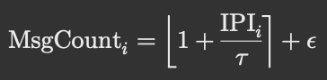
where:
- Ť is a scaling constant (15 minutes),
- 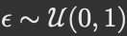 introduces bounded randomness,
- values are clipped to a predefined range.
- Log-Scaled Transaction Amount: Natural logarithm of the transaction amount to reduce skewness and stabilize learning.
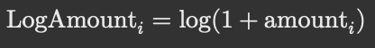
- Account-Level Amount Z-Score: Z-score normalization of transaction amount within each bank account to capture anomalous deviations.
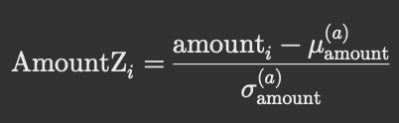
where:
- 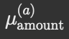 is the mean transaction amount for account a,
- 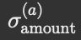 is the standard deviation.
- σ= 0, the value is set to 0.
- Account-Level IPI Z-Score : Z-score normalization of inter-payment intervals per account to highlight unusual urgency patterns. All features were sanitized to remove infinite values and normalized using Min–Max scaling prior to model training.
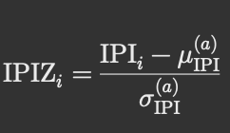
where:
- 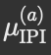 is the mean IPI for account a,
-  is the standard deviation.
Again, if σ = 0, the value is safely set to 0.
All features are normalized using Min–Max scaling:
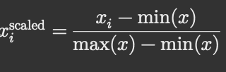
This ensures:
- Stable gradient optimization for classical models
- Stable angle encoding for quantum circuits

C. Train–Test Split and Scaling
The dataset was partitioned into training and testing subsets using an 80/20 stratified split to preserve the original class imbalance. All feature transformations and scaling parameters were learned exclusively from the training set and subsequently applied to the test set to prevent information leakage. Feature scaling was performed using Min–Max normalization, mapping all input features to the [0,1] range. This step is critical for both classical and quantum models, as it ensures numerical stability during optimization and encoding.
For classical models such as Logistic Regression and Support Vector Machines, scaling stabilizes gradient-based optimization by preventing features with larger numeric ranges from disproportionately influencing parameter updates. Without normalization, large-magnitude features can dominate gradient computations, leading to unstable convergence and suboptimal decision boundaries.
For the Quantum Neural Network, feature scaling is essential due to the use of angle encoding, where classical features are mapped directly to rotation angles in the quantum circuit. Unscaled feature values can produce excessively large rotation angles, causing rapid oscillations of quantum states on the Bloch sphere and resulting in noisy gradients or barren plateau effects. By constraining feature values to a bounded range, the quantum circuit evolves smoothly, enabling more reliable parameter optimization and stable training behavior.
Thus, consistent feature scaling ensures fair comparison across classical and quantum models while maintaining numerical and physical stability during both training and inference.

D. Classical Machine Learning Models
Two classical baselines were implemented:

Logistic Regression : A logistic regression classifier with L_2 regularization was used as a linear baseline. The model was trained using maximum likelihood estimation with a convergence cap of 1,000 iterations.

Support Vector Machine (RBF Kernel) : A nonlinear Support Vector Machine with a Radial Basis Function (RBF) kernel was used to capture complex decision boundaries. Default hyperparameters were retained to focus on architectural comparison rather than tuning.

Quantum Neural Network Model
The Quantum Neural Network (QNN) was implemented using PennyLane and executed on the default.qubit state-vector simulator. The model consisted of:
- 6 qubits, corresponding to the six input features
- Angle encoding, where each feature was encoded as a rotation around the Y-axis
- Variational layers composed of parameterized single-qubit rotations (RY and RZ) followed by linear entanglement using CNOT gates
The circuit output was measured as the expectation value of the Pauli-Z operator on the first qubit and mapped to a probability score.

Model Architecture

Training Procedure
The QNN was trained using a simplified gradient-free optimization strategy suitable for small datasets and stable simulator execution. Multiple iterations were performed, and the set of parameters minimizing the binary cross-entropy loss was retained. The final prediction was obtained by thresholding the output probability at 0.5.

Results
This section presents a comparative evaluation of classical machine learning models and a quantum neural network (QNN) for Advance-Fee Fraud (AFF) detection using a six-feature representation derived from transactional behavior.

5.1 Experimental Setup:
All models were evaluated on a dataset of 2,000 transaction samples, split into training and testing sets using an 80/20 stratified split to preserve class imbalance. Six engineered features were used consistently across all models, including inter-payment interval (IPI), response time, message count proxy, log-scaled transaction amount, and account-level z-score normalizations. The models were evaluated:
- Logistic Regression (6F) – linear baseline
- Support Vector Machine with RBF kernel (6F) – nonlinear classical baseline
- Quantum Neural Network (6-Qubit, 6F) – Variational quantum classifier executed on a state-vector quantum simulator. The QNN was implemented using PennyLane and executed on the default.qubit simulator, representing an ideal noiseless quantum device.

5.2 Classification Performance

5.2.1 Overall Classification Accuracy Across Classical, Neural, and Quantum Models (6 Features)

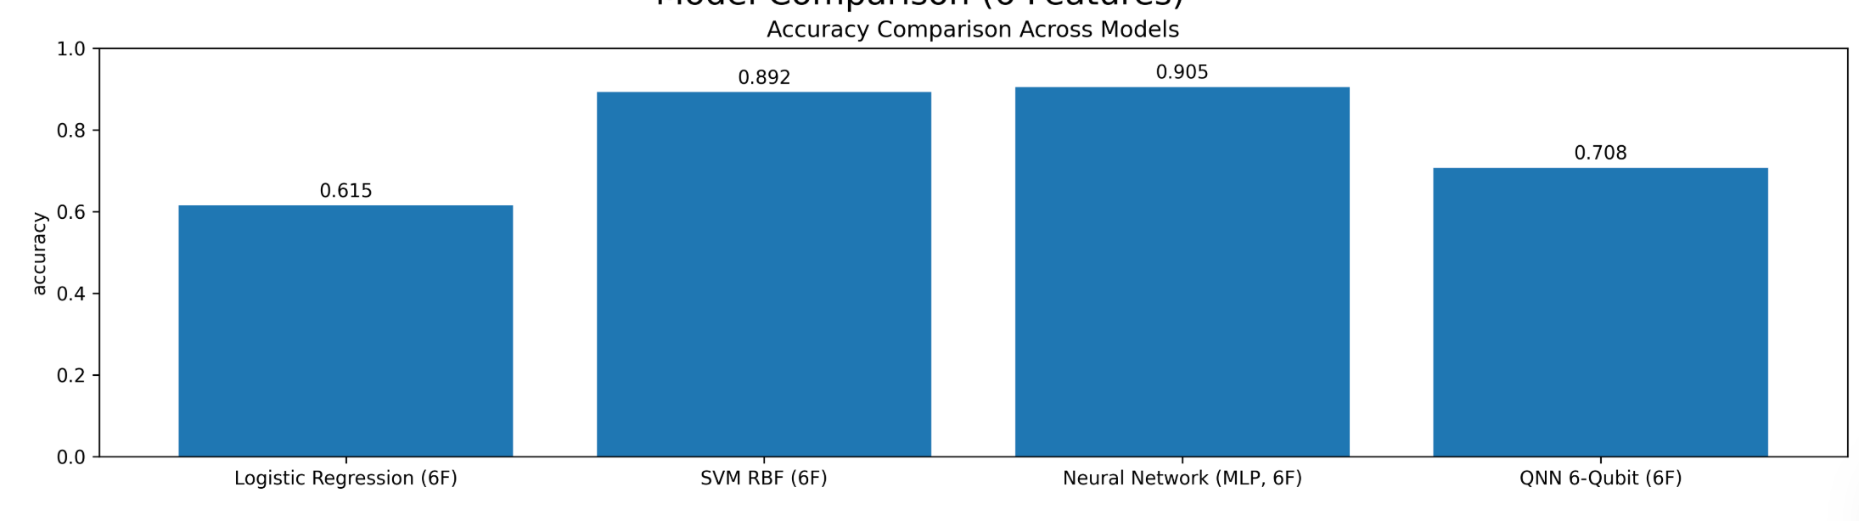

5.2.2 Precision, Recall, and F1-Score Comparison Across Learning Paradigms (6 Features)

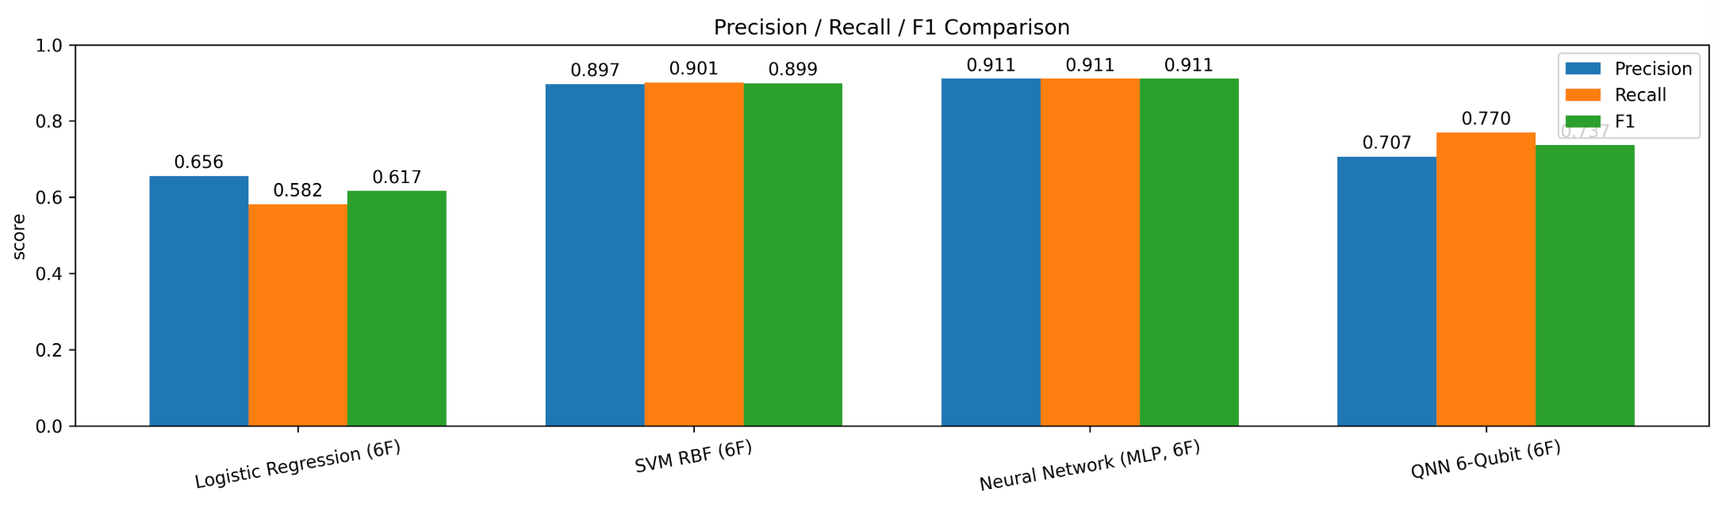

5.3 Inference Time per Prediction: Computational Cost Comparison of Classical, Neural, and Quantum Models

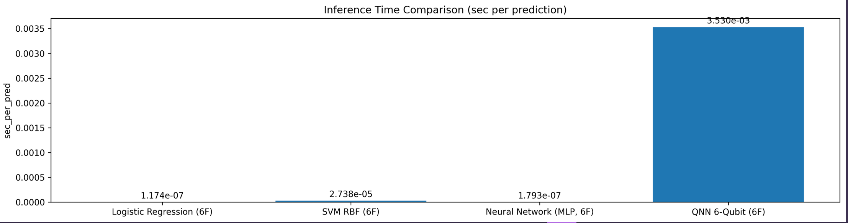

QNN Performance Scaling with Number of Qubits
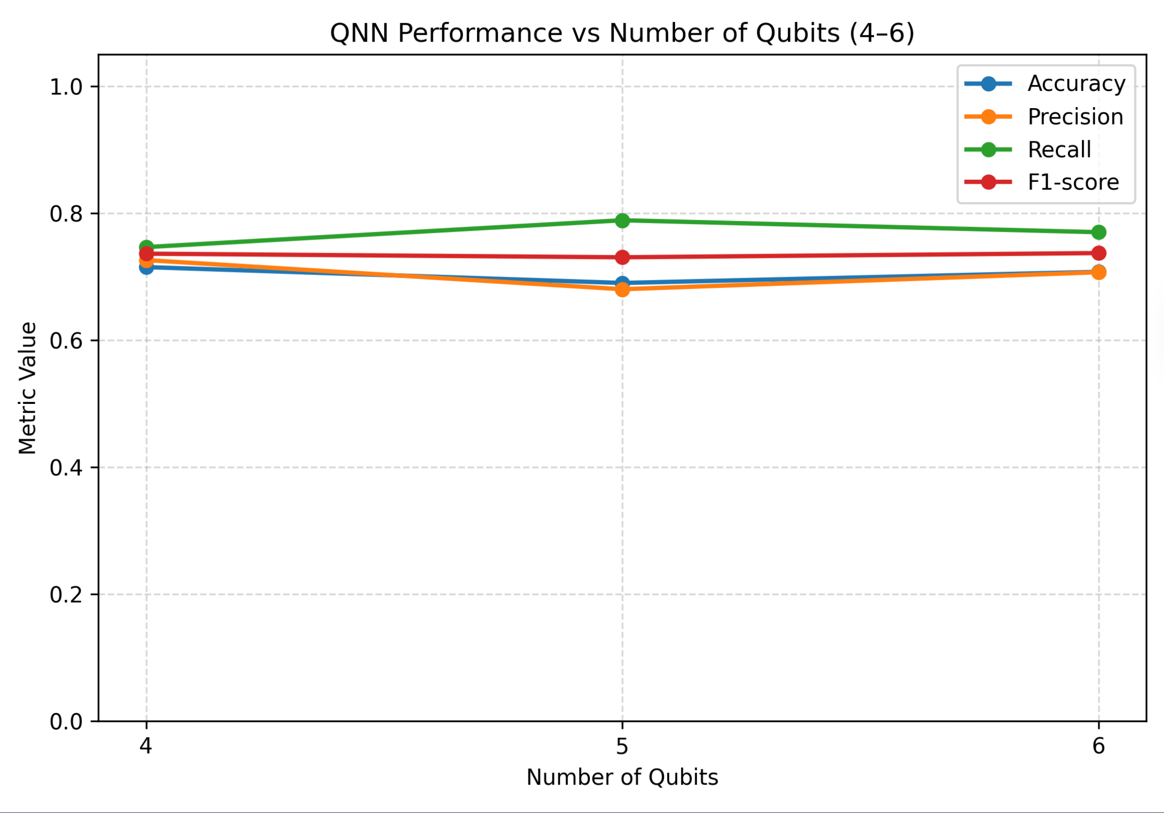
Figure 1:Accuracy, precision, recall, and F1-score of the Quantum Neural Network evaluated on 4, 5, and 6 qubits. The results indicate a performance plateau rather than monotonic improvement, highlighting the trade-off between circuit expressivity and optimization stability.

QNN Training Dynamics: Loss Convergence Over Optimization Steps
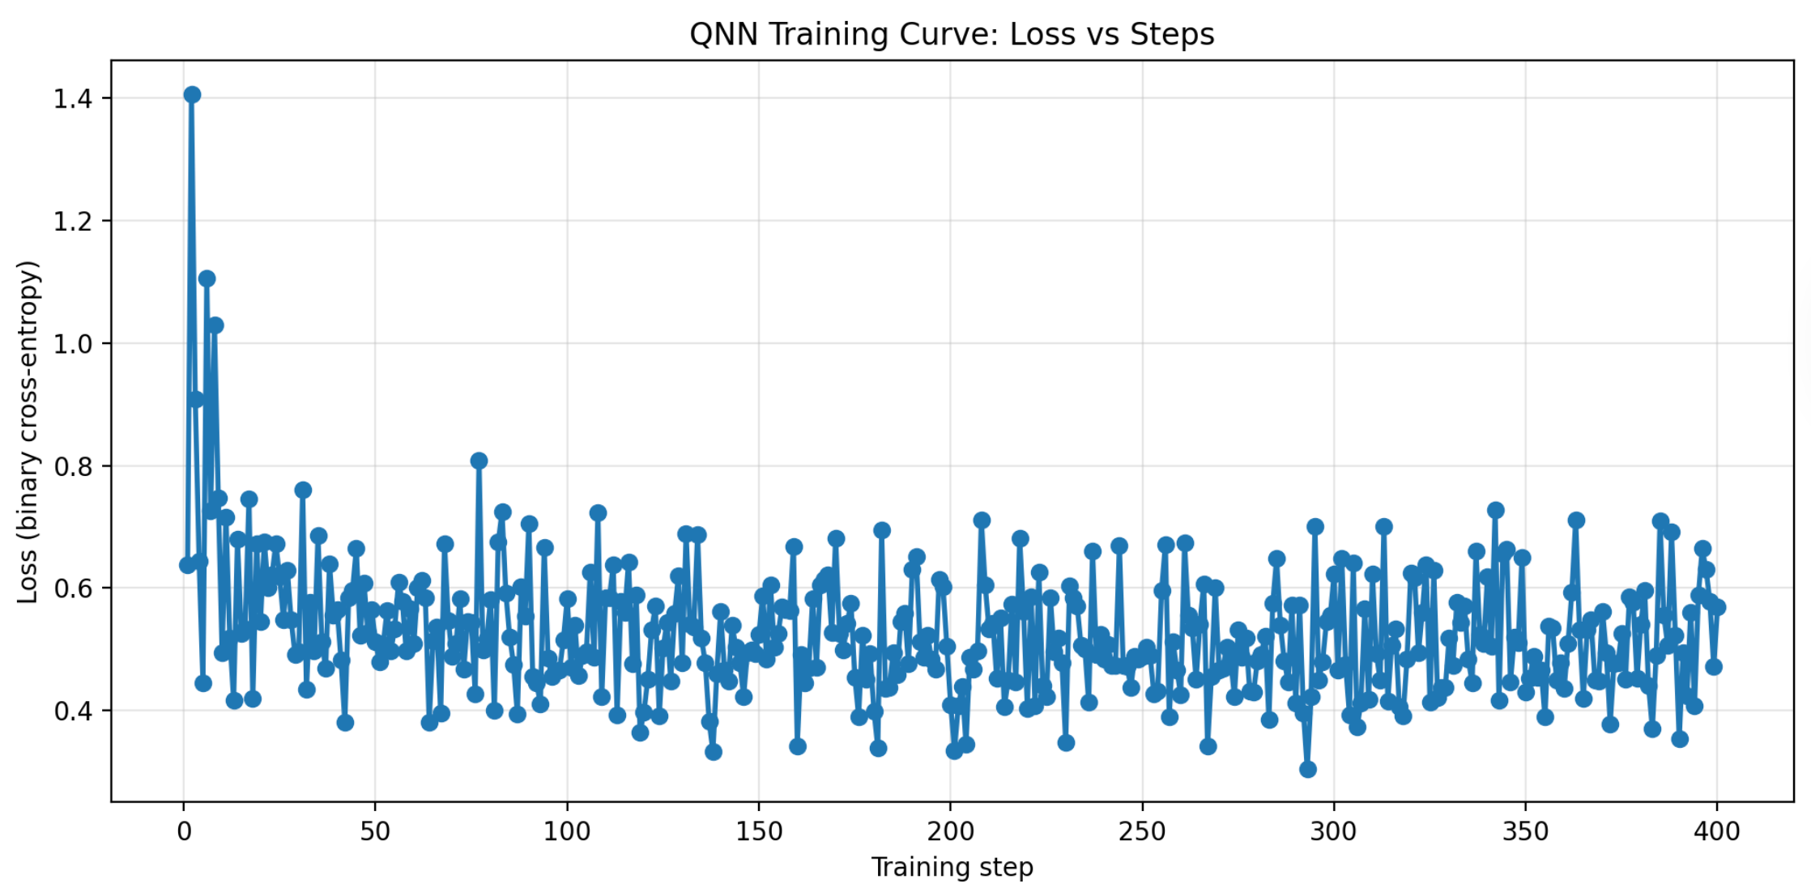
Figure 2: Binary cross-entropy loss during QNN training over 400 optimization steps. The sharp initial decrease followed by bounded oscillations indicates successful convergence within a noisy, non-convex quantum optimization landscape.

Performance Comparison Between Quantum and Classical Neural Networks
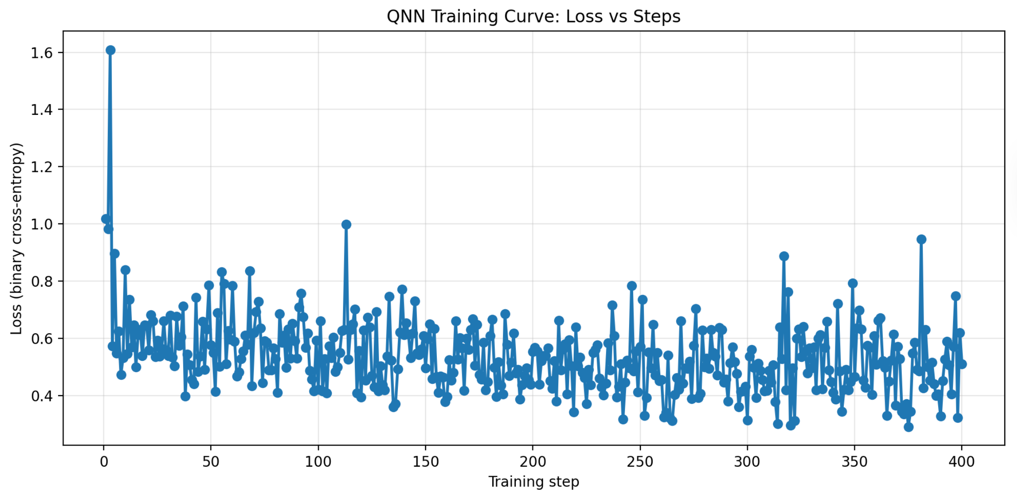
Figure 3: Comparison of classification metrics between a classical multilayer perceptron and a 6-qubit Quantum Neural Network. Although the classical model achieves higher accuracy, the QNN demonstrates competitive recall, validating its potential under near-term quantum constraints.

Training Dynamics of the Quantum Neural Network: Loss Convergence Over Optimization Steps
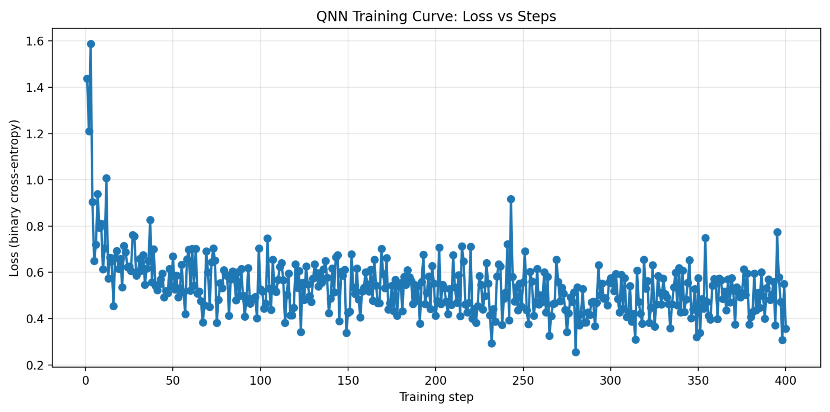
Figure 4: This figure illustrates the training behavior of the Quantum Neural Network (QNN) using a binary cross-entropy loss function over 400 optimization steps. The loss decreases rapidly during the initial training phase, followed by convergence to a stable region with noticeable fluctuations. These oscillations reflect the noisy and non-convex optimization landscape of variational quantum circuits, even when trained on an analytic quantum simulator. Despite the absence of smooth monotonic convergence, the overall stabilization of loss indicates that the QNN successfully learns a meaningful decision boundary.

Comparison of Quantum Neural Network (QNN) and Classical Neural Network (MLP) Performance

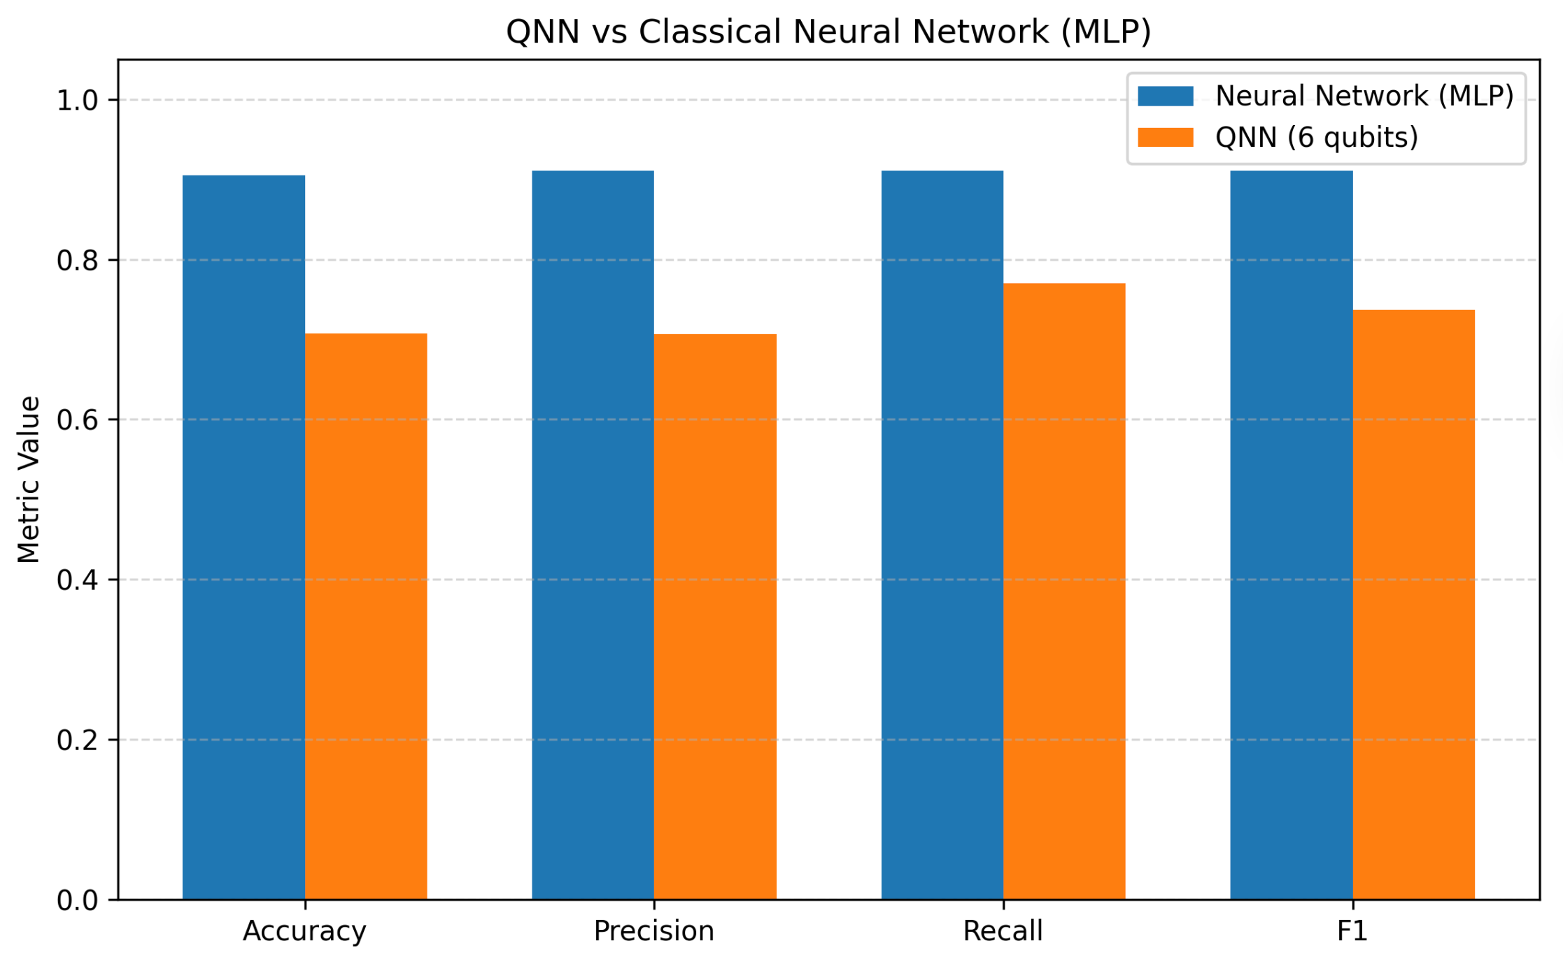

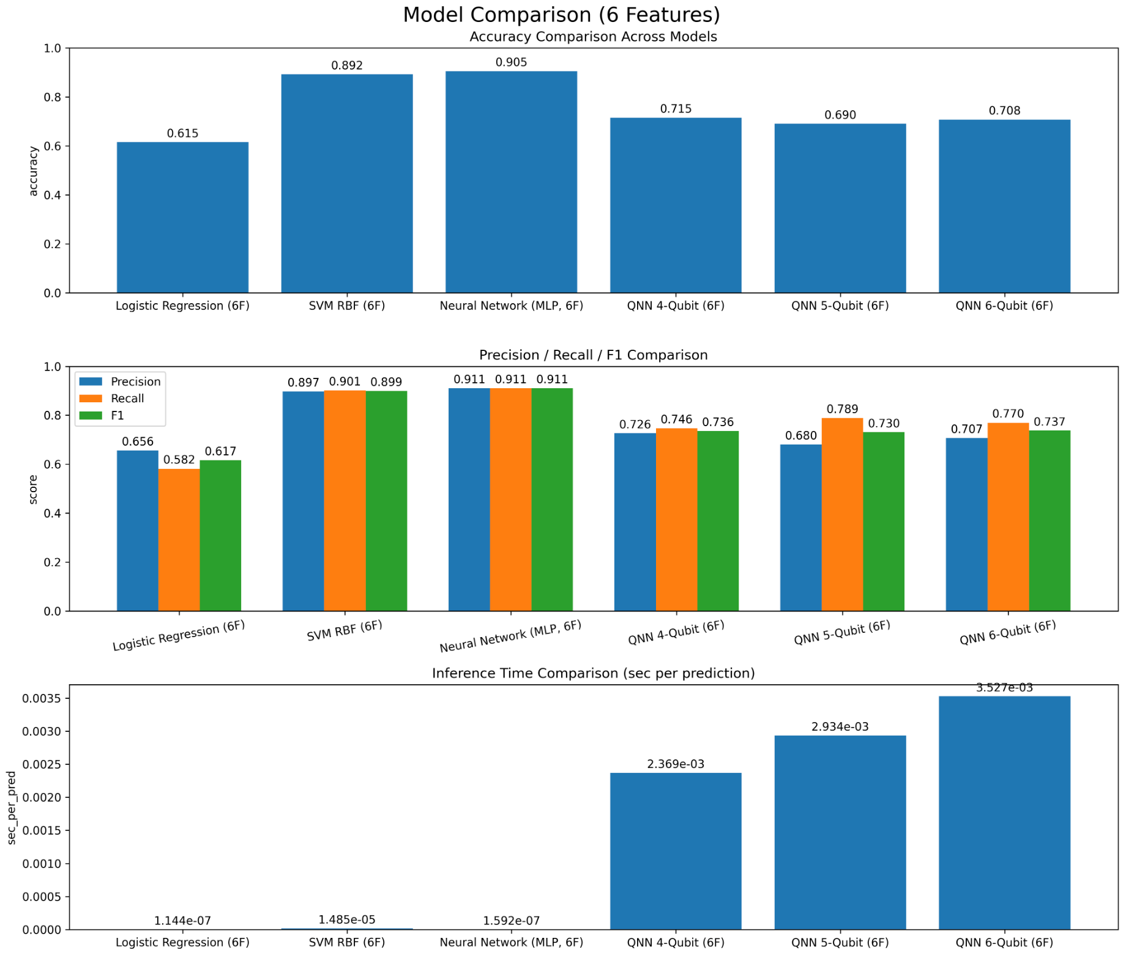

5.4 Summary of Findings

5.5 Key Observations
- Classical models remain superior for structured transactional data under current conditions.
- The QNN exhibits higher fraud sensitivity (recall), which is valuable in high-risk financial applications.
- Quantum models incur significantly higher inference costs when executed on simulators.
- The observed trade-offs reflect fundamental limitations of circuit depth, optimization landscapes, and simulator overhead.

Future Work

Conclusion
This study examined the potential of Quantum Neural Networks (QNNs) to detect Advance-Fee Fraud (AFF) in its earliest stages using the Inter-Payment Interval (IPI) as a primary behavioral feature, and compared their performance with classical machine learning models such as Logistic Regression and Support Vector Machines (SVM). Results indicate that when limited to a single behavioral indicator, all models—including the QNN—achieve modest classification accuracy, highlighting the difficulty of early-stage fraud prediction with minimal data. However, QNNs demonstrated competitive expressive capability relative to Logistic Regression, while SVMs risked overfitting despite appearing to perform strongly.
A key finding concerns classification speed: SVM inference became faster when additional numerical features were introduced, while QNN inference remained significantly slower due to classical simulation overhead. These results suggest that although QNNs show theoretical promise for modeling complex boundaries, their practical deployment for real-time fraud detection remains constrained by current hardware limitations.
Overall, this work provides a foundational comparison of quantum and classical models for behavioral fraud analytics and highlights the potential benefits of integrating quantum feature encoding with richer numerical and categorical indicators. As quantum hardware evolves, QNNs may become viable components of future financial crime detection pipelines, offering improved expressivity and adaptiveness for modeling high-pressure scam behaviors. The insights gained here form an early step toward real-world quantum-assisted fraud prevention systems.

References
[1] R. Leukfeldt and T. Jansen, “Advance fee fraud: Understanding the victimization process,” Journal of Financial Crime, vol. 27, no. 3, pp. 807–822, 2020.
[2] C. Hadnagy, Social Engineering: The Science of Human Hacking, 2nd ed. Hoboken, NJ, USA: Wiley, 2018.
[3] A. Narayanan, K. Chandrasekaran, and M. P. Kumar, “Behavior-based fraud detection using temporal patterns in financial transactions,” in Proc. IEEE Int. Conf. Data Mining Workshops, 2019, pp. 310–317.
[4] B. F. M. Anusha and B. S. Amutha, “Machine learning based financial fraud detection: A systematic review,” Int. J. Innovative Technology and Exploring Engineering, vol. 9, no. 3, pp. 1500–1506, 2020.
[5] V. Vapnik, The Nature of Statistical Learning Theory. New York, NY, USA: Springer, 1995.
[6] D. W. Hosmer, S. Lemeshow, and R. X. Sturdivant, Applied Logistic Regression, 3rd ed. New York, NY, USA: Wiley, 2013.
[7] M. Schuld, I. Sinayskiy, and F. Petruccione, “The quest for a quantum neural network,” Quantum Information Processing, vol. 13, no. 11, pp. 2567–2586, 2014.
[8] M. Schuld and N. Killoran, “Quantum machine learning in feature Hilbert spaces,” Phys. Rev. Lett., vol. 122, no. 4, p. 040504, 2019.
[9] A. Abbas et al., “The power of quantum neural networks,” Nature Computational Science, vol. 1, pp. 403–409, 2021.
[10] J. Preskill, “Quantum computing in the NISQ era and beyond,” Quantum, vol. 2, p. 79, 2018.
[11] V. Bergholm et al., “PennyLane: Automatic differentiation of hybrid quantum–classical computations,” arXiv preprint arXiv:1811.04968, 2019.
[12] S. Lloyd, M. Mohseni, and P. Rebentrost, “Quantum algorithms for supervised and unsupervised machine learning,” arXiv preprint arXiv:1307.0411, 2013.
[13] Federal Bureau of Investigation (FBI), Internet Crime Complaint Center (IC3), “2024 Internet Crime Report,” 2024. [Online]. Available: https://www.ic3.gov
[14] Unknown, “Social Engineering Lifecycle Diagram,” 2024. [Online]. Available: https://www.google.com/search?q=how+social+engineering+happen+in+cyber+security+Advance+fee+attack+diagram
[15]https://quantum.cloud.ibm.com/learning/en/courses/quantum-machine-learning/data-encoding

[16] https://quantum.cloud.ibm.com/learning/en/courses/quantum-machine-learning/data-encoding

.

